Official league roster - Basketball
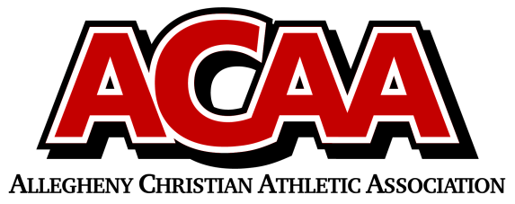

School Name: Blair County Christian
Team Colors: Green/White
Overall Wins ___ Losses ____ Ties ___
ACAA Wins ___ Losses ____ Ties ___ OPPONENT: __________________________
Date: _________
Number | Name | Year | Position | Height | Homeschool
0 | Caedmon Dull | 12 | G | 6’0”
1 | Ealor Burket | 12 | G | 5’8”
3 | Braxton Walter | 10 | G | 5’6”
5 | Caleb Hileman | 9 | F | 6’0”
13 | Jonathan Marucci | 9 | F | 6’1”
15 | Aidyn Lundy | 9 | F | 6’0”
21 | Julian Sponsler | 9 | G | 5’6”
31 | Seth Nicodemus | 11 | F | 5’10”
32 | Matthias Andre | 12 | C | 6’2”
33 | Micaiah Marucci | 12 | F | 6’2”

Head Coach: ANDREW fRIES
Asst. coach: bARRY yINGLING

